https://whatartcando.org/2020/10/a-10-point-case-for-cultural-learning-for-kids-and-young-people/

A 10-point case for cultural learning for kids and young people
by Jasper Visser | Oct 21, 2020 | Research | 0 Comments
It is often said that the best way to ensure people participate in art and culture throughout their life is to engage them when they are young. Research seems to confirm this claim. Exposing kids to art at a young age helps them to develop a positive attitude towards the arts. That’s wonderful, of course, but we do not want art education only for art’s sake. We want art to do more.
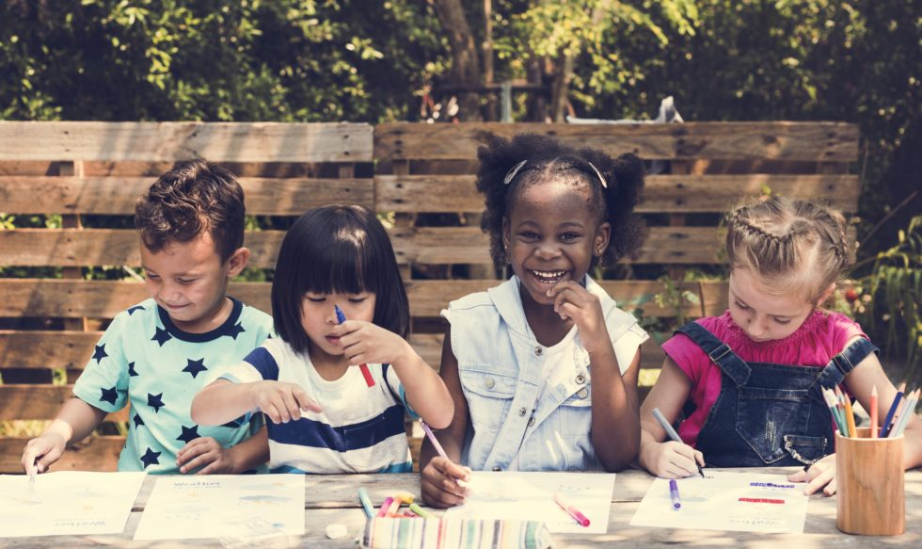
Fortunately, for years the Cultural Learning Alliance has been championing the role of the arts, culture and heritage in the development of kids and young people. A handy PDF with their key findings of decades of research makes a compelling case for the use of art and culture in learning.
Their research has the CLA conclude that “The arts and heritage are an intrinsic part of how we come to know and understand the world and how we express ourselves as individuals, communities and a nation.”
Apart from enjoyment and inspiration, the arts enable children to develop their creativity and imagination. There are also substantial and compelling educational, employment and civic benefits to learning through and about culture. The CLA shares ten need-to-know effects:
- Participation in structured arts activities can increase cognitive abilities by 17%.
- Learning through arts and culture can improve attainment in Maths and English.
- Learning through arts and culture develops skills and behaviour that lead children to do better in school.
- Students from low-income families who take part in arts activities at school are three times more likely to get a degree.
- Employability of students who study arts subjects is higher, and they are more likely to stay in employment.
- Students from low-income families who engage in the arts at school are twice as likely to volunteer.
- Students from low-income families who engage in the arts at school are 20% more likely to vote as young adults.
- Young offenders who take part in arts activities are 18% less likely to re-offend.
- Children who take part in arts activities in the home during their early years are ahead in reading and Maths at age nine.
- People who take part in the arts are 38% more likely to report good health.
In their PDF, the CLA provides additional information, nuances, and sources for each of these points. Let’s communicate them widely, so nobody will question the value of the arts and culture for learning ever again!

